**St. Anne’s Degree College for Women**



**St. Anne’s Degree College for Women**



Affiliated to Bengaluru Central University

Recognized by UGC under Section 2(f), Accredited by NAAC

**Halasuru, Bangalore-560008**

**Self-Study Report – Cycle-II**

**ALUMNAE REPORT**

**(2015-2020)**

**St. Anne’s Degree College for Women**



Affiliated to Bengaluru Central University

Recognized by UGC under Section 2(f), Accredited by NAAC

**Halasuru, Bangalore-560008**

**Self-Study Report – Cycle-II**

**ALUMNAE REPORT (2015-2020)**

|  |  |
| --- | --- |
| **Year** | **Page Number** |
| 2019-2020 | 1-4 |
| 2018-2019 | 5-7 |
| 2017-2018 | 8-9 |
| 2016-2017 | 10-11 |
| 2015-2016 | 12-14 |

**St. Anne’s Degree College for Women**



Affiliated to Bengaluru Central University

Recognized by UGC under Section 2(f), Accredited by NAAC

**Halasuru, Bangalore-560008**

**Self-Study Report – Cycle-II**

**ALUMNAE REPORT 2019-2020**

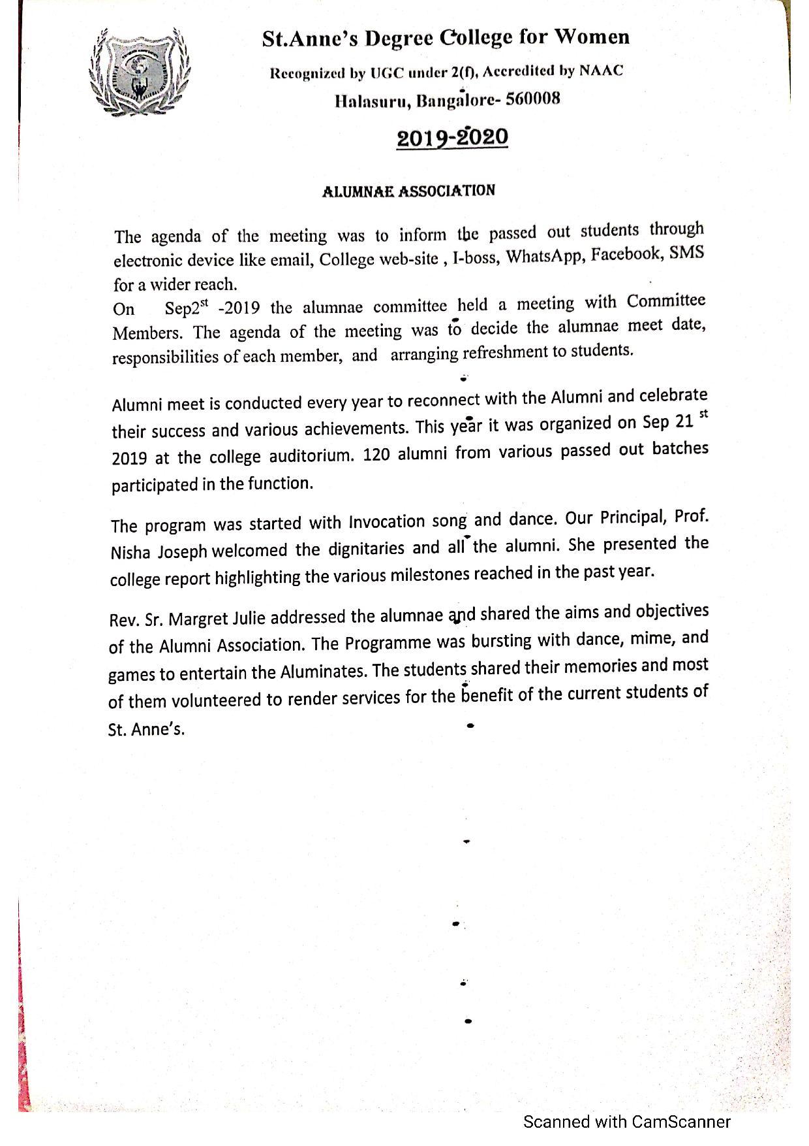

**1**

**St. Anne’s Degree College for Women**



Affiliated to Bengaluru Central University

Recognized by UGC under Section 2(f), Accredited by NAAC

**Halasuru, Bangalore-560008**

**Self-Study Report – Cycle-II**

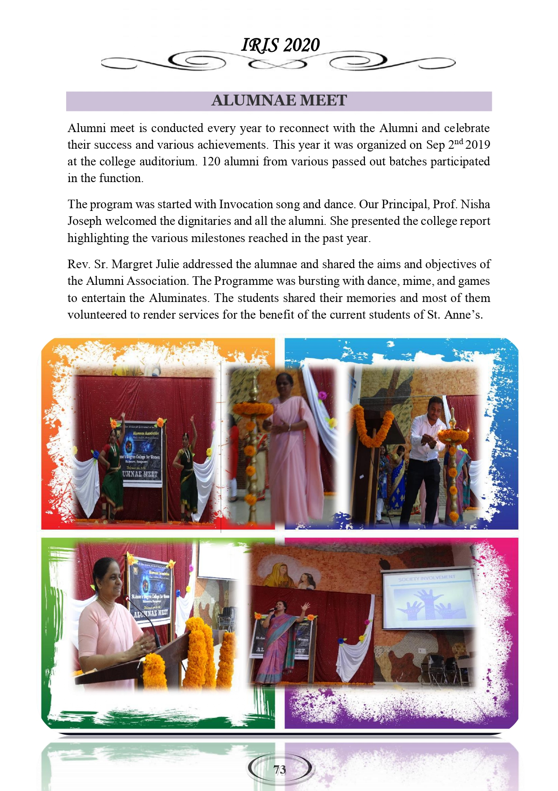**ALUMNAE MEET ORGANIZED ON 2nd SEMPTEMBER 2019**

**2**

**St. Anne’s Degree College for Women**



Affiliated to Bengaluru Central University

Recognized by UGC under Section 2(f), Accredited by NAAC

**Halasuru, Bangalore-560008**

**Self-Study Report – Cycle-II**

**ALUMNAE SHARING MEMORIES**

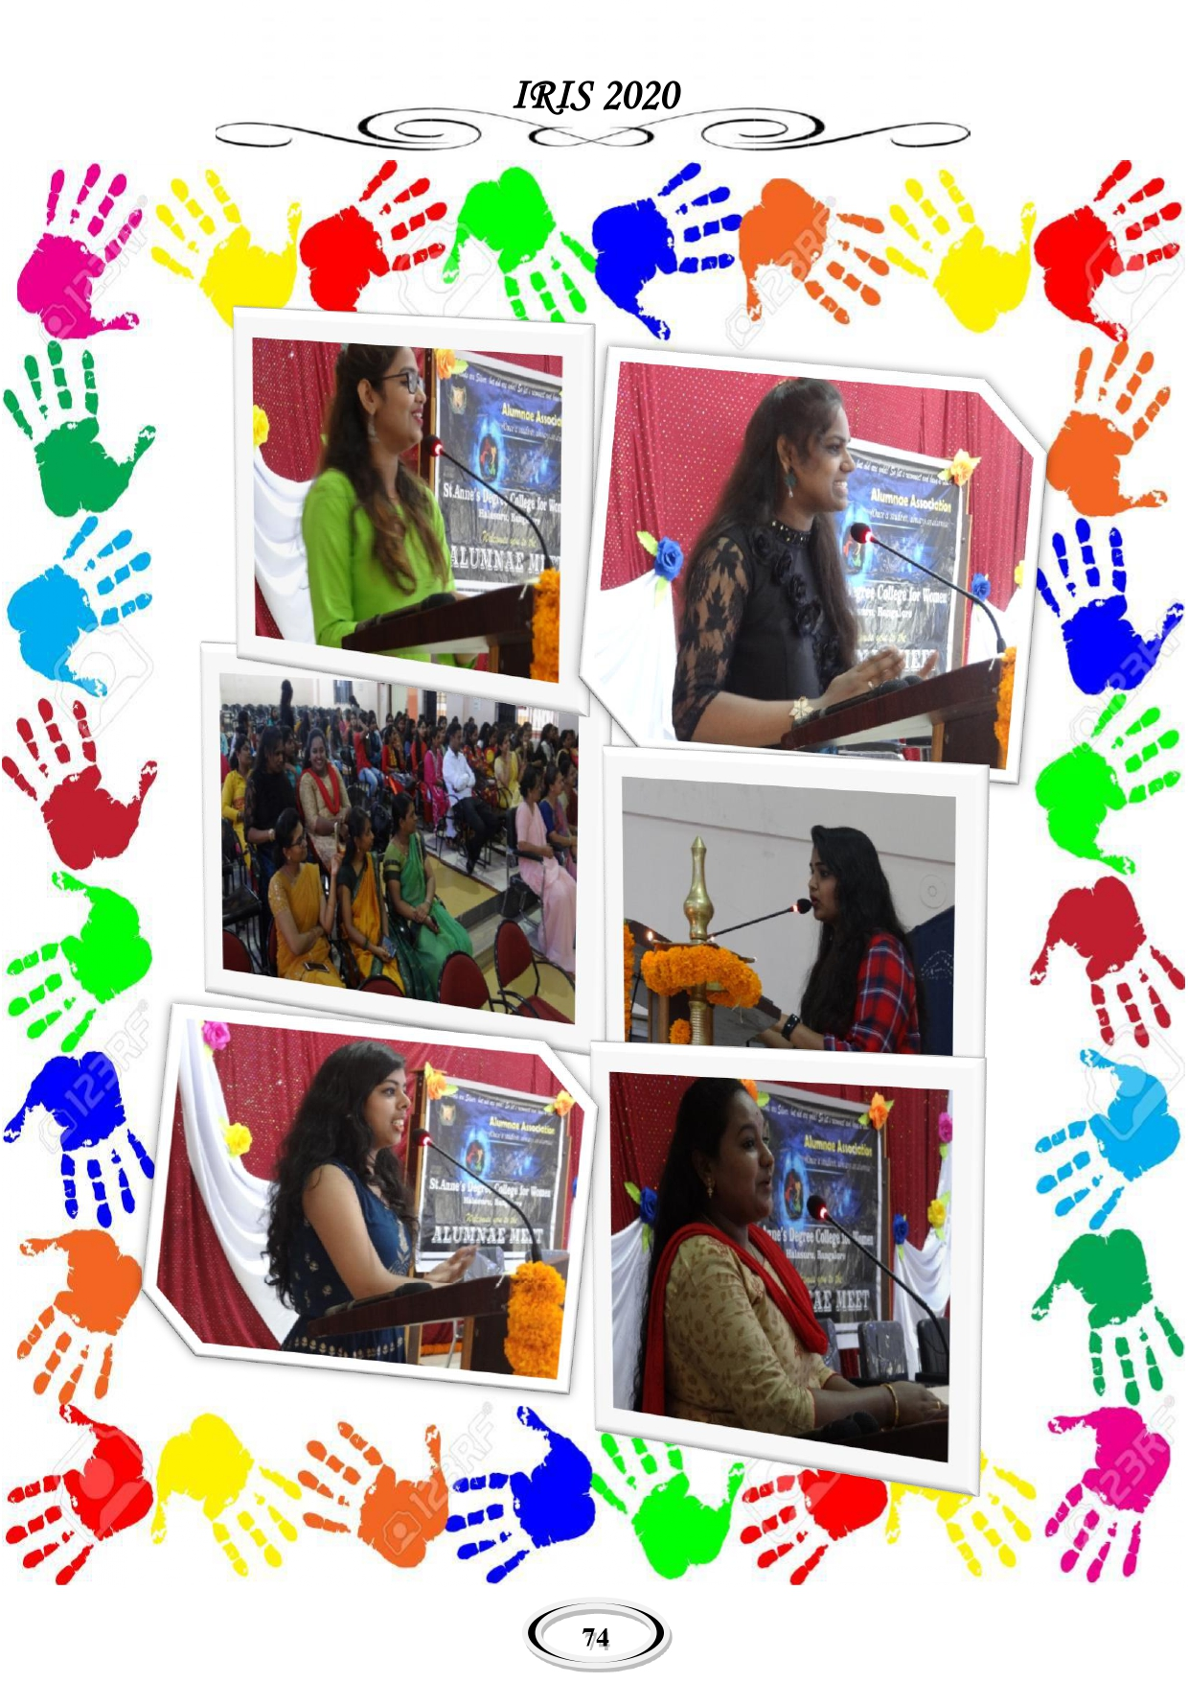

**3**

**St. Anne’s Degree College for Women**



Affiliated to Bengaluru Central University

Recognized by UGC under Section 2(f), Accredited by NAAC

**Halasuru, Bangalore-560008**

**Self-Study Report – Cycle-II**

**ALUMNAE CONDUCTED WEBINAR ON 11th JULY 2020**

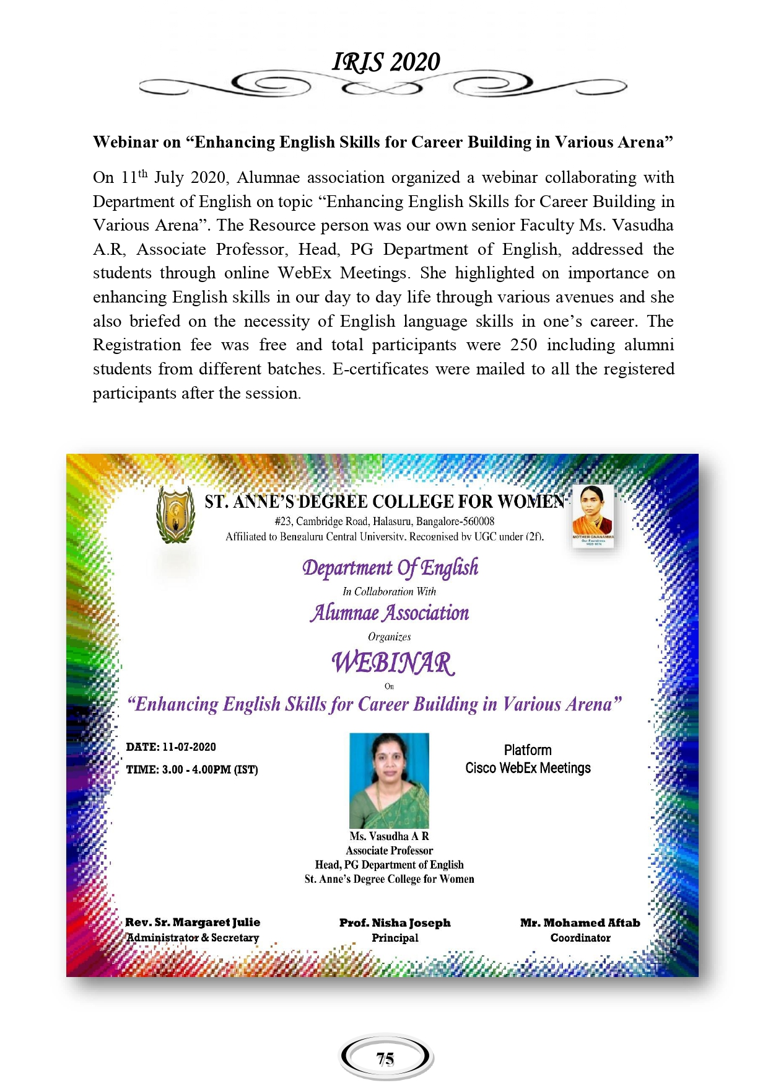

**4**

**St. Anne’s Degree College for Women**



Affiliated to Bengaluru Central University

Recognized by UGC under Section 2(f), Accredited by NAAC

**Halasuru, Bangalore-560008**

**Self-Study Report – Cycle-II**

**ALUMNAE REPORT 2018-2019**

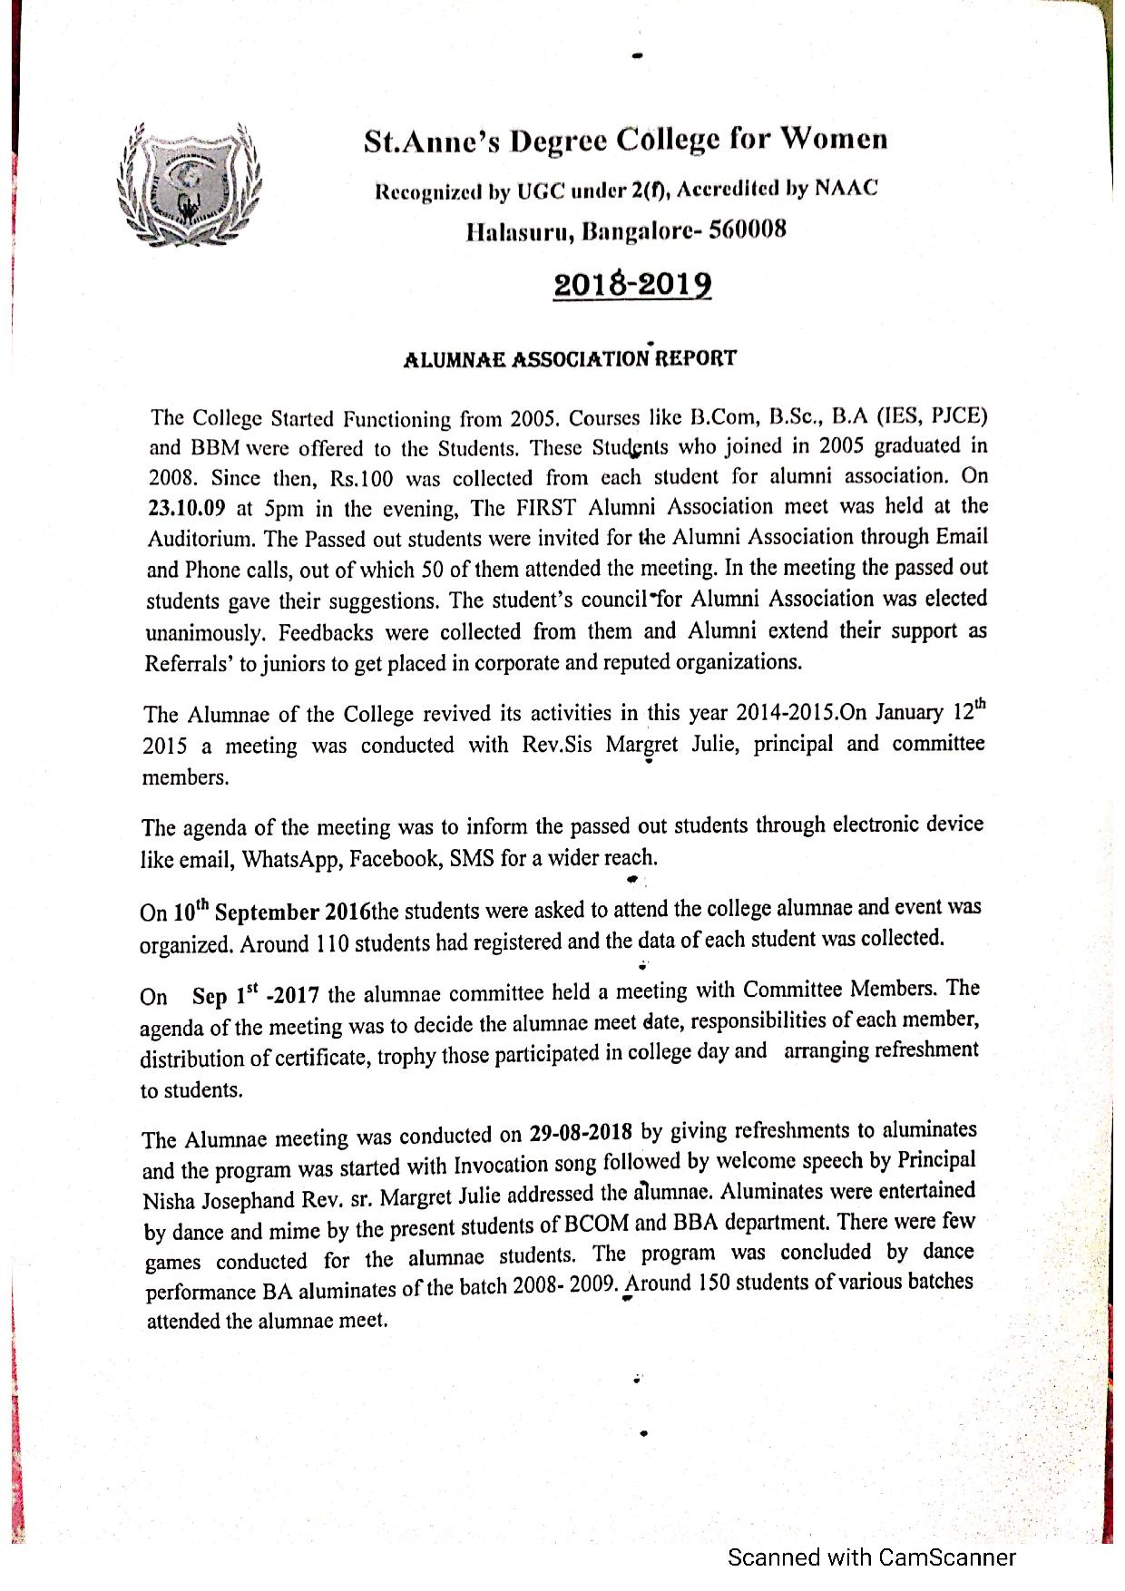

**5**

**St. Anne’s Degree College for Women**



Affiliated to Bengaluru Central University

Recognized by UGC under Section 2(f), Accredited by NAAC

**Halasuru, Bangalore-560008**

**Self-Study Report – Cycle-II**

**ALUMNAE ON 29th August 2018**

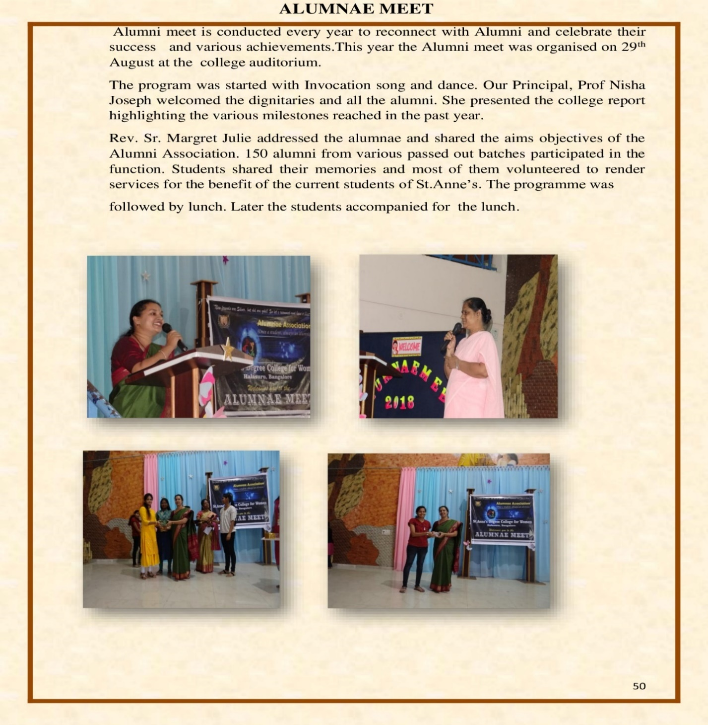

**6**

**St. Anne’s Degree College for Women**



Affiliated to Bengaluru Central University

Recognized by UGC under Section 2(f), Accredited by NAAC

**Halasuru, Bangalore-560008**

**Self-Study Report – Cycle-II**

**ALUMNAE DANCE EVENT**

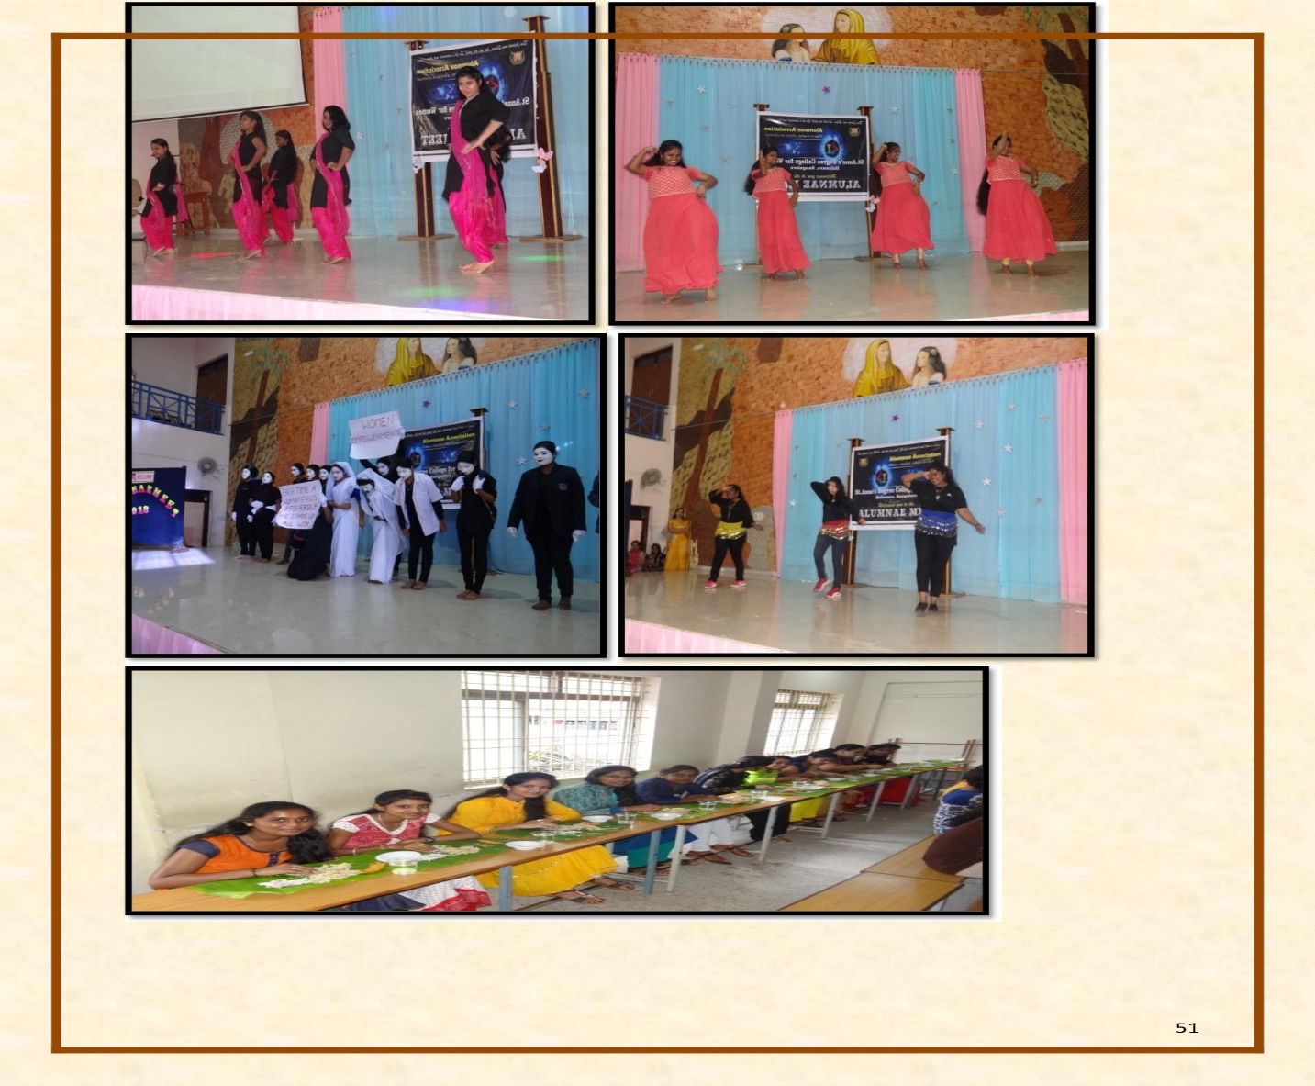

**7**

**St. Anne’s Degree College for Women**



Affiliated to Bengaluru Central University

Recognized by UGC under Section 2(f), Accredited by NAAC

**Halasuru, Bangalore-560008**

**Self-Study Report – Cycle-II**

**ALUMNAE 2017-2018**

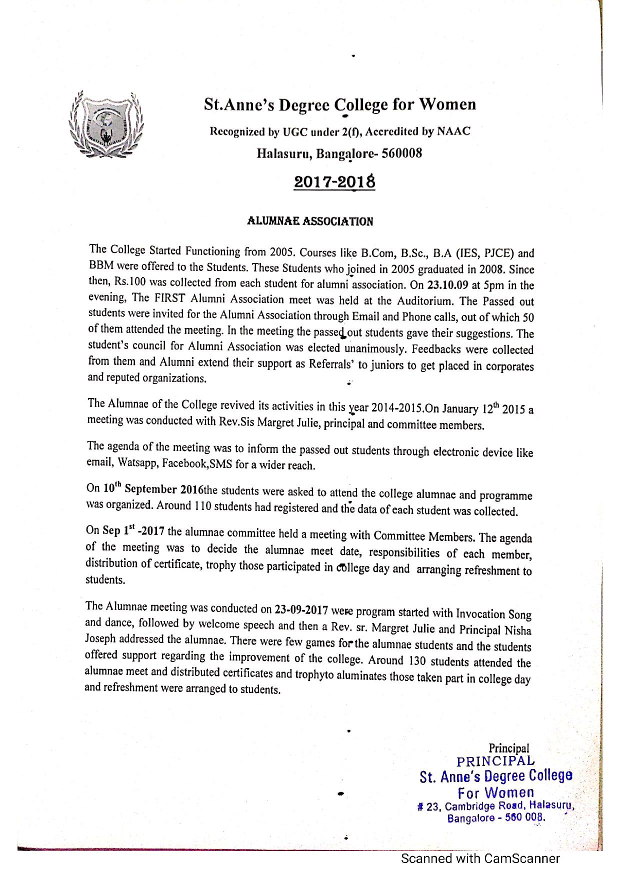

**8**

**St. Anne’s Degree College for Women**



Affiliated to Bengaluru Central University

Recognized by UGC under Section 2(f), Accredited by NAAC

**Halasuru, Bangalore-560008**

**Self-Study Report – Cycle-II**

**ALUMNAE MEET ORGANIZED ON 23rd SEPTEMBER 2017**

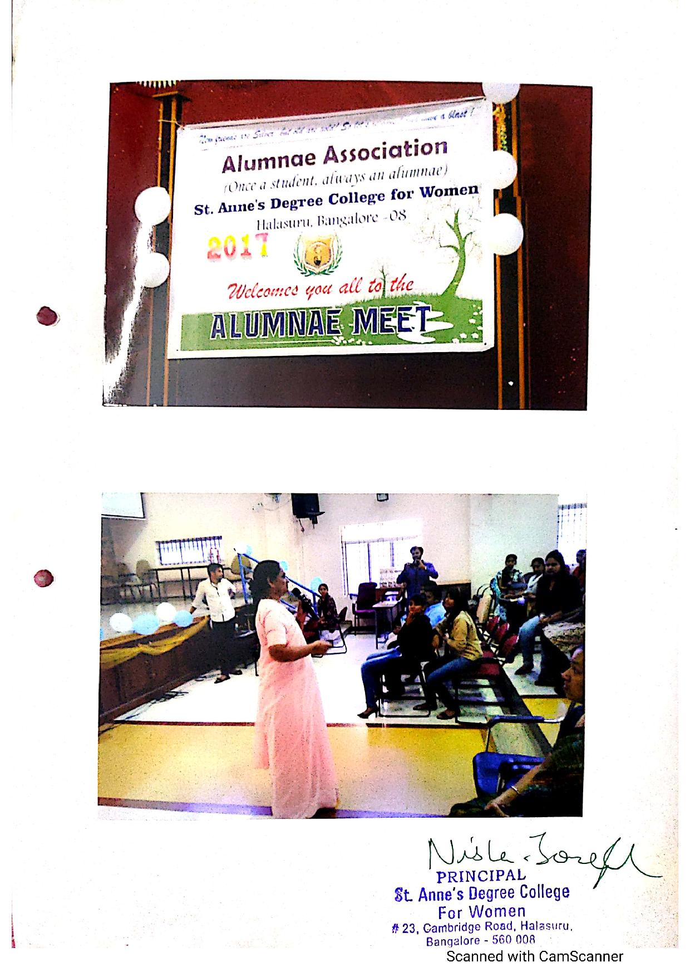

**9**

**St. Anne’s Degree College for Women**



Affiliated to Bengaluru Central University

Recognized by UGC under Section 2(f), Accredited by NAAC

**Halasuru, Bangalore-560008**

**Self-Study Report – Cycle-II**

**ALUMNAE REPORT 2016-2017**

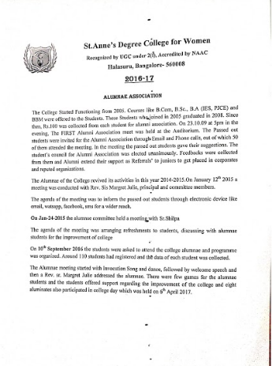

**10**

**St. Anne’s Degree College for Women**



Affiliated to Bengaluru Central University

Recognized by UGC under Section 2(f), Accredited by NAAC

**Halasuru, Bangalore-560008**

**Self-Study Report – Cycle-II**

**ALUMNAE MEET ORGANIZED ON 10th SEPTEMBER 2016**

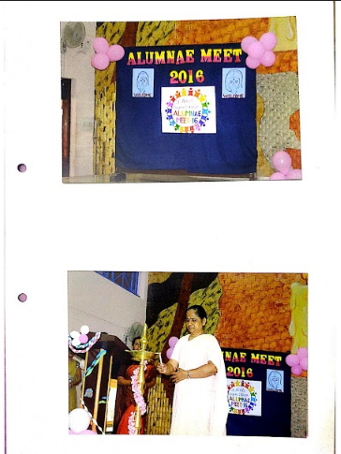

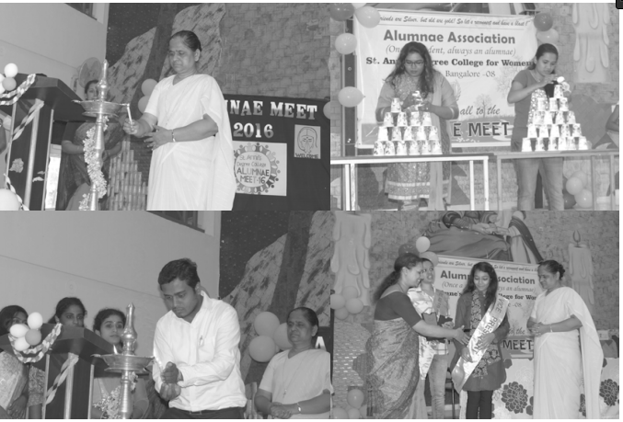

**11**

**St. Anne’s Degree College for Women**



Affiliated to Bengaluru Central University

Recognized by UGC under Section 2(f), Accredited by NAAC

**Halasuru, Bangalore-560008**

**Self-Study Report – Cycle-II**

**ALUMNAE REPORT 2015-2016**

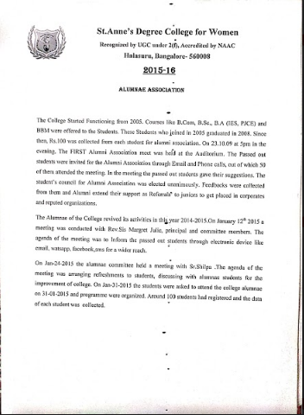

**12**

**St.Anne’s Degree College for Women**



Affiliated to Bengaluru Central University

Recognized by UGC under Section 2(f), Accredited by NAAC

**Halasuru, Bangalore-560008**

**Self Study Report – Cycle-II**

**ALUMNAE MEET ORGANIZED ON 19th SEPTEMBER 2015**

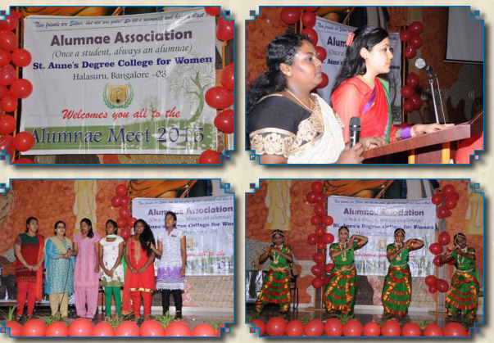

**13**

**St.Anne’s Degree College for Women**



Affiliated to Bengaluru Central University

Recognized by UGC under Section 2(f), Accredited by NAAC

**Halasuru, Bangalore-560008**

**Self Study Report – Cycle-II**

**ALUMNAE MEET ORGANIZED ON 19th SEPTEMBER 2015**

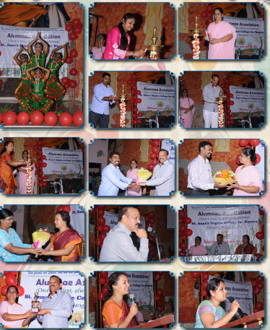 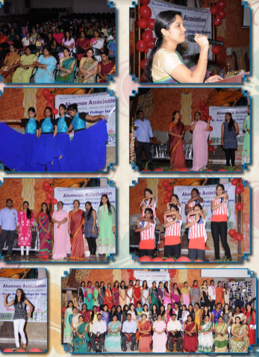

**14**

**St.Anne’s Degree College for Women**



Affiliated to Bengaluru Central University

Recognized by UGC under Section 2(f), Accredited by NAAC

**Halasuru, Bangalore-560008**

**Self Study Report – Cycle-II**

**ALUMNAE FEEDBACK**

**(2015-2020)**

**St.Anne’s Degree College for Women**



Affiliated to Bengaluru Central University

Recognized by UGC under Section 2(f), Accredited by NAAC

**Halasuru, Bangalore-560008**

**Self Study Report – Cycle-II**

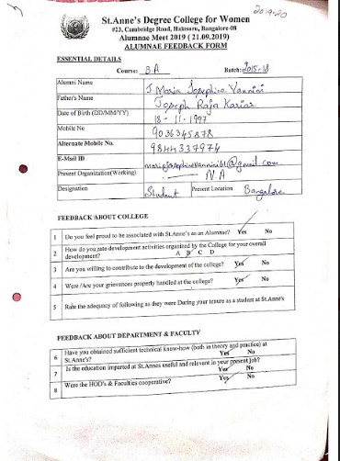

**St.Anne’s Degree College for Women**



Affiliated to Bengaluru Central University

Recognized by UGC under Section 2(f), Accredited by NAAC

**Halasuru, Bangalore-560008**

**Self Study Report – Cycle-II**

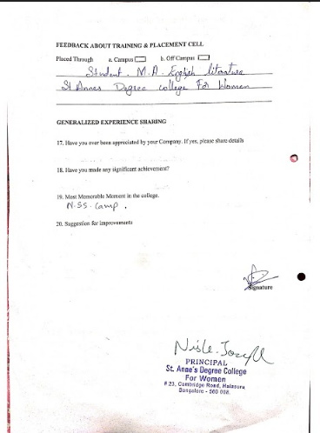

**St.Anne’s Degree College for Women**



Affiliated to Bengaluru Central University

Recognized by UGC under Section 2(f), Accredited by NAAC

**Halasuru, Bangalore-560008**

**Self Study Report – Cycle-II**

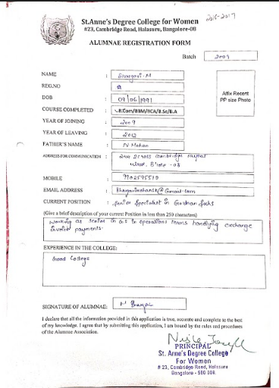

**St.Anne’s Degree College for Women**



Affiliated to Bengaluru Central University

Recognized by UGC under Section 2(f), Accredited by NAAC

**Halasuru, Bangalore-560008**

**Self Study Report – Cycle-II**

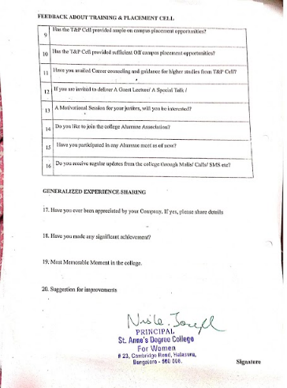

**St.Anne’s Degree College for Women**



Affiliated to Bengaluru Central University

Recognized by UGC under Section 2(f), Accredited by NAAC

**Halasuru, Bangalore-560008**

**Self Study Report – Cycle-II**

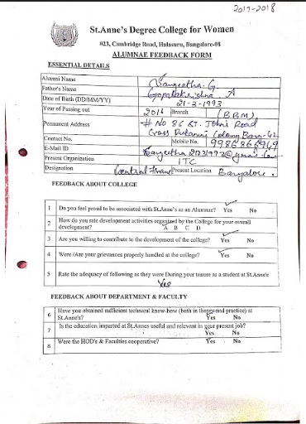

**St.Anne’s Degree College for Women**



Affiliated to Bengaluru Central University

Recognized by UGC under Section 2(f), Accredited by NAAC

**Halasuru, Bangalore-560008**

**Self Study Report – Cycle-II**

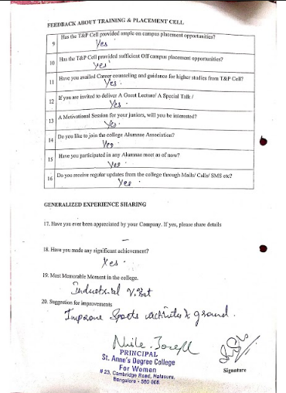

**St.Anne’s Degree College for Women**



Affiliated to Bengaluru Central University

Recognized by UGC under Section 2(f), Accredited by NAAC

**Halasuru, Bangalore-560008**

**Self Study Report – Cycle-II**

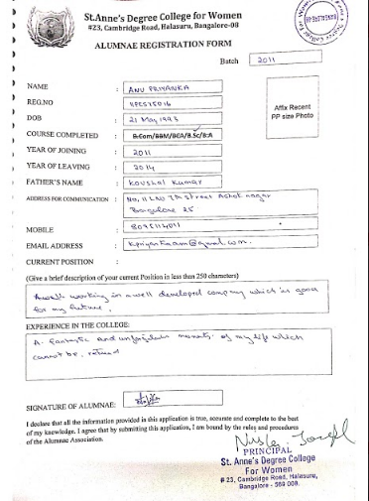

**St.Anne’s Degree College for Women**



Affiliated to Bengaluru Central University

Recognized by UGC under Section 2(f), Accredited by NAAC

**Halasuru, Bangalore-560008**

**Self Study Report – Cycle-II**

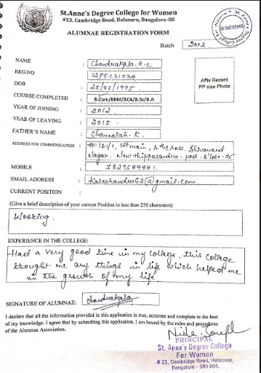

**St.Anne’s Degree College for Women**



Affiliated to Bengaluru Central University

Recognized by UGC under Section 2(f), Accredited by NAAC

**Halasuru, Bangalore-560008**

**Self Study Report – Cycle-II**

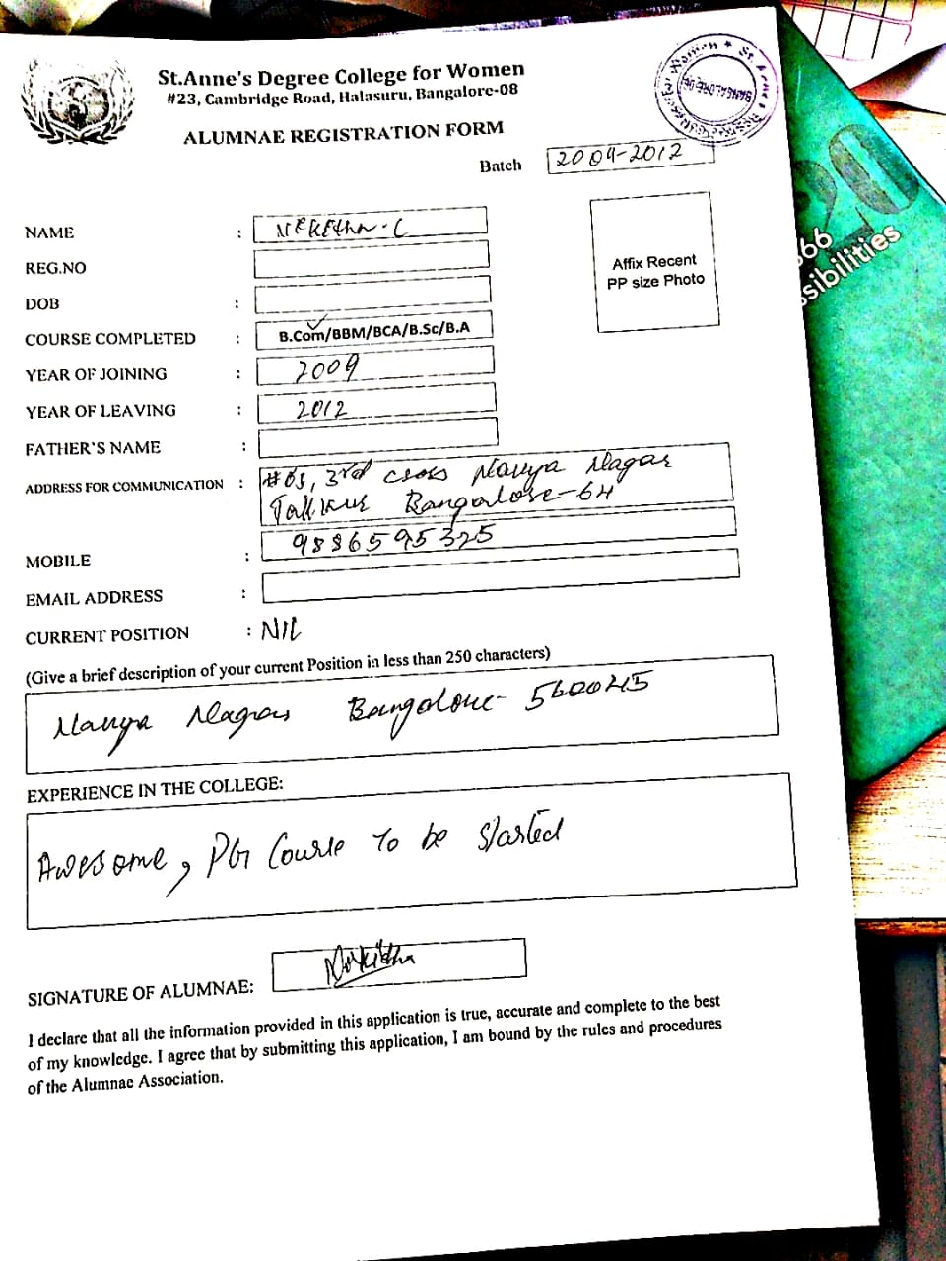

**St.Anne’s Degree College for Women**



Affiliated to Bengaluru Central University

Recognized by UGC under Section 2(f), Accredited by NAAC

**Halasuru, Bangalore-560008**

**Self Study Report – Cycle-II**

